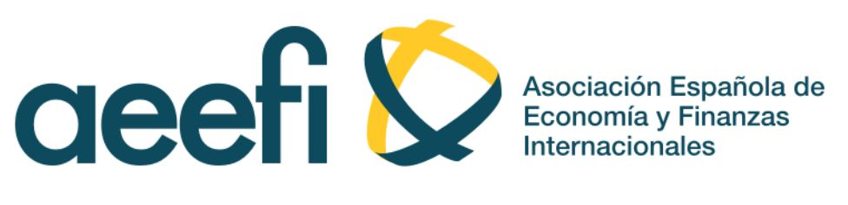

Please, complete the affiliation form and send by e-mail to:

María Santana Gallego
Departamento de Economía Aplicada
Universitat de les Illes Balears;
Edificio Jovellanos. Campus UIB
Carretera Valldemossa km 7.5, 07122 Palma (islas Baleares)
E-mail: maria.santana@uib.es

Payments:

- Direct bank transfer to the AEEFI bank account. Send the receipt of the subscription fee by email:

Bank | BANKIA  SWIFT/CIF Code: CAHMESMM
IBAN | ES67 2100 7084 5113 0029 6175
Account name: | Asociación Española de Economía y Finanzas Internacionales
Address | Instituto de Economía Internacional (IEI). Universitat Jaume I  Avda. Sos Baynat, s/n  12071 Castellón

Affiliation form

Name Surname

Institution

Department

Address

Postal Code City Country

E-mail

